**Company Data**

**Analysis**

**FRA 2**

Name: Saurabh Dharmadhikari

PGP-DSBA Online January’ 21

Table of Contents:

Problem Statement……………………...................................................................................................................................3

Data Description ............................................................................................................................................................4

Sample Data. …………………………………………………………………………………………………………………………………………….............5

Data Summary: ……………………….…………………………………………………………………………………………………………………………….7

Outliers ………………………..………………………………………………………………......…………………………………………………………........10

Missing value treatment. …………………………………….....................................................................................................13

Univariant and bivariant analysis. ..............................................................................................................................14

Scatter Plot:. …………………………………...........................................................................................................................17

Heat Map of Correlation. ............................................................................................................................................21

Train and Test Split …………………………………………………………………………........................................................................22

Linear Regression Model. …………….............................................................................................................................22

Model 1 ………………………………………………………………………………………………………………………………………………………………..24

Model 2 Using REF …………………………….………………………………………………………………………………………………………………….24

Model 3 Using SMOTE (75:25) ……………..……………………………………………………………………………………………………………….25

Model 4 SMOTE (65:35) ………………………………………………………………………………………………………………………………………..26

Model Validation …..………………………………………………………………………………………………………………………………………………26

Problem Statement

Businesses or companies can fall prey to default if they are not able to keep up their debt obligations. Defaults will lead to a lower credit rating for the company, which in turn reduces its chances of getting credit in the future and may have to pay higher interests on existing debts as well as any new obligations. From an investor's point of view, he would want to invest in a company if it is capable of handling its financial obligations, can grow quickly, and is able to manage the growth scale. A balance sheet is a financial statement of a company that provides a snapshot of what a company owns, owes, and the amount invested by the shareholders. Thus, it is an important tool that helps evaluate the performance of a business. Data that is available includes information from the financial statement of the companies for the previous year (2015). Also, information about the Net worth of the company in the following year (2016) is provided which can be used to drive the labelled field.

Data Description:

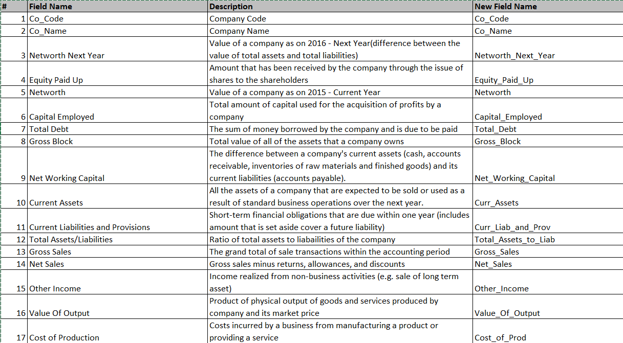

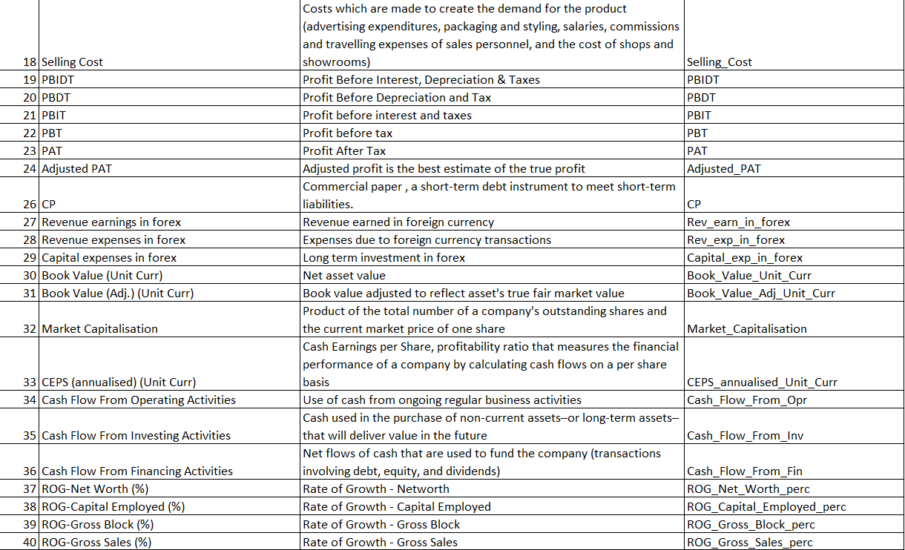

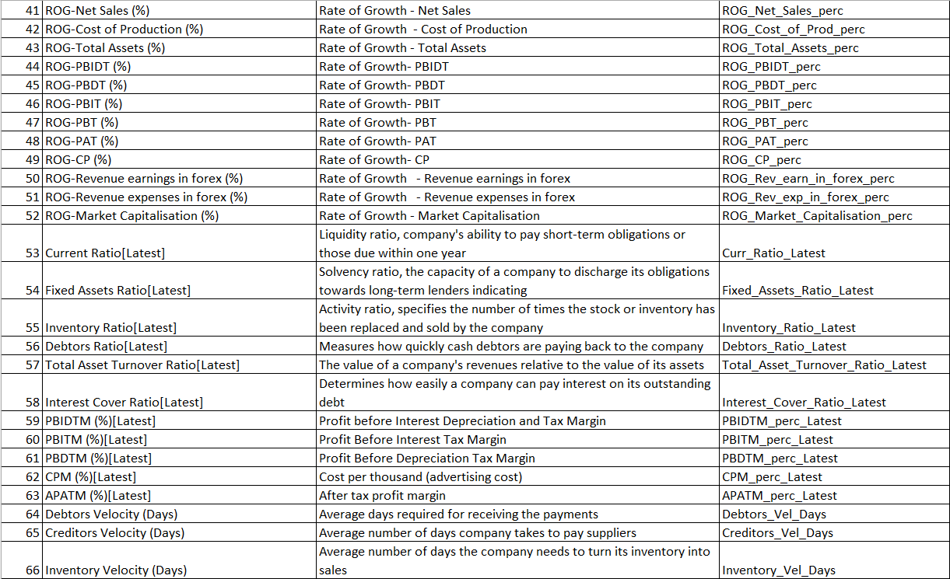



Sample Data

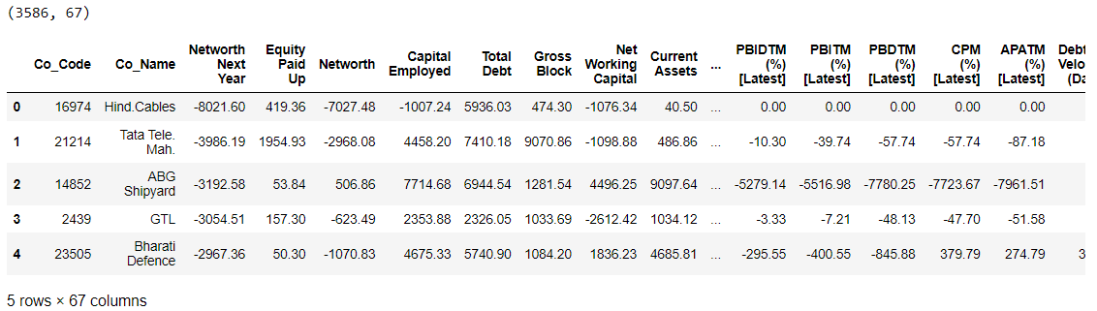

We have already cleaned the data.

RangeIndex: 3586 entries, 0 to 3585

Data columns (total 67 columns):

# Column Non-Null Count Dtype

--- ------ -------------- -----

0 CO_CODE 3586 non-null int64

1 CO_NAME 3586 non-null object

2 NETWORTH_NEXT_YEAR 3586 non-null float64

3 EQUITY_PAID_UP 3586 non-null float64

4 NETWORTH 3586 non-null float64

5 CAPITAL_EMPLOYED 3586 non-null float64

6 TOTAL_DEBT 3586 non-null float64

7 GROSS_BLOCK 3586 non-null float64

8 NET_WORKING_CAPITAL 3586 non-null float64

9 CURRENT_ASSETS 3586 non-null float64

10 CURRENT_LIABILITIES_AND_PROVISIONS 3586 non-null float64

11 TOTAL_ASSETS_BY_LIABILITIES 3586 non-null float64

12 GROSS_SALES 3586 non-null float64

13 NET_SALES 3586 non-null float64

14 OTHER_INCOME 3586 non-null float64

15 VALUE_OF_OUTPUT 3586 non-null float64

16 COST_OF_PRODUCTION 3586 non-null float64

17 SELLING_COST 3586 non-null float64

18 PBIDT 3586 non-null float64

19 PBDT 3586 non-null float64

20 PBIT 3586 non-null float64

21 PBT 3586 non-null float64

22 PAT 3586 non-null float64

23 ADJUSTED_PAT 3586 non-null float64

24 CP 3586 non-null float64

25 REVENUE_EARNINGS_IN_FOREX 3586 non-null float64

26 REVENUE_EXPENSES_IN_FOREX 3586 non-null float64

27 CAPITAL_EXPENSES_IN_FOREX 3586 non-null float64

28 BOOK_VALUE_UNIT_CURR 3586 non-null float64

29 BOOK_VALUE_ADJ_UNIT_CURR 3582 non-null float64

30 MARKET_CAPITALISATION 3586 non-null float64

31 CEPS_ANNUALISED_UNIT_CURR 3586 non-null float64

32 CASH_FLOW_FROM_OPERATING_ACTIVITIES 3586 non-null float64

33 CASH_FLOW_FROM_INVESTING_ACTIVITIES 3586 non-null float64

34 CASH_FLOW_FROM_FINANCING_ACTIVITIES 3586 non-null float64

35 ROG_NET_WORTH_PERC 3586 non-null float64

36 ROG_CAPITAL_EMPLOYED_PERC 3586 non-null float64

37 ROG_GROSS_BLOCK_PERC 3586 non-null float64

38 ROG_GROSS_SALES_PERC 3586 non-null float64

39 ROG_NET_SALES_PERC 3586 non-null float64

40 ROG_COST_OF_PRODUCTION_PERC 3586 non-null float64

41 ROG_TOTAL_ASSETS_PERC 3586 non-null float64

42 ROG_PBIDT_PERC 3586 non-null float64

43 ROG_PBDT_PERC 3586 non-null float64

44 ROG_PBIT_PERC 3586 non-null float64

45 ROG_PBT_PERC 3586 non-null float64

46 ROG_PAT_PERC 3586 non-null float64

47 ROG_CP_PERC 3586 non-null float64

48 ROG_REVENUE_EARNINGS_IN_FOREX_PERC 3586 non-null float64

49 ROG_REVENUE_EXPENSES_IN_FOREX_PERC 3586 non-null float64

50 ROG_MARKET_CAPITALISATION_PERC 3586 non-null float64

51 CURRENT_RATIO_LATEST 3585 non-null float64

52 FIXED_ASSETS_RATIO_LATEST 3585 non-null float64

53 INVENTORY_RATIO_LATEST 3585 non-null float64

54 DEBTORS_RATIO_LATEST 3585 non-null float64

55 TOTAL_ASSET_TURNOVER_RATIO_LATEST 3585 non-null float64

56 INTEREST_COVER_RATIO_LATEST 3585 non-null float64

57 PBIDTM_PERC_LATEST 3585 non-null float64

58 PBITM_PERC_LATEST 3585 non-null float64

59 PBDTM_PERC_LATEST 3585 non-null float64

60 CPM_PERC_LATEST 3585 non-null float64

61 APATM_PERC_LATEST 3585 non-null float64

62 DEBTORS_VELOCITY_DAYS 3586 non-null int64

63 CREDITORS_VELOCITY_DAYS 3586 non-null int64

64 INVENTORY_VELOCITY_DAYS 3483 non-null float64

65 VALUE_OF_OUTPUT_BY_TOTAL_ASSETS 3586 non-null float64

66 VALUE_OF_OUTPUT_BY_GROSS_BLOCK 3586 non-null float64

dtypes: float64(63), int64(3), object(1)

There is only 1 categorical column all other columns are numeric in nature.

**Data Summary:**

|  | **count** | **mean** | **std** | **min** | **25%** | **50%** | **75%** | **max** |
| --- | --- | --- | --- | --- | --- | --- | --- | --- |
| **NETWORTH_NEXT_YEAR** | 3586.0 | 725.05 | 4769.68 | -8021.60 | 3.98 | 19.02 | 123.80 | 111729.10 |
| **EQUITY_PAID_UP** | 3586.0 | 62.97 | 778.76 | 0.00 | 3.75 | 8.29 | 19.52 | 42263.46 |
| **NETWORTH** | 3586.0 | 649.75 | 4091.99 | -7027.48 | 3.89 | 18.58 | 117.30 | 81657.35 |
| **CAPITAL_EMPLOYED** | 3586.0 | 2799.61 | 26975.14 | -1824.75 | 7.60 | 39.09 | 226.60 | 714001.25 |
| **TOTAL_DEBT** | 3586.0 | 1994.82 | 23652.84 | -0.72 | 0.03 | 7.49 | 72.35 | 652823.81 |
| **GROSS_BLOCK** | 3586.0 | 594.18 | 4871.55 | -41.19 | 0.57 | 15.87 | 131.90 | 128477.59 |
| **NET_WORKING_CAPITAL** | 3586.0 | 410.81 | 6301.22 | -13162.42 | 0.94 | 10.14 | 61.18 | 223257.56 |
| **CURRENT_ASSETS** | 3586.0 | 1960.35 | 22577.57 | -0.91 | 4.00 | 24.54 | 135.28 | 721166.00 |
| **CURRENT_LIABILITIES_AND_PROVISIONS** | 3586.0 | 391.99 | 2675.00 | -0.23 | 0.73 | 9.23 | 65.65 | 83232.98 |
| **TOTAL_ASSETS_BY_LIABILITIES** | 3586.0 | 1778.45 | 11437.57 | -4.51 | 10.56 | 52.01 | 310.54 | 254737.22 |
| **GROSS_SALES** | 3586.0 | 1123.74 | 10603.70 | -62.59 | 1.44 | 31.21 | 242.25 | 474182.94 |
| **NET_SALES** | 3586.0 | 1079.70 | 9996.57 | -62.59 | 1.44 | 30.44 | 234.44 | 443775.16 |
| **OTHER_INCOME** | 3586.0 | 48.73 | 426.04 | -448.72 | 0.02 | 0.45 | 3.64 | 14143.40 |
| **VALUE_OF_OUTPUT** | 3586.0 | 1077.19 | 9843.88 | -119.10 | 1.41 | 30.90 | 235.84 | 435559.09 |
| **COST_OF_PRODUCTION** | 3586.0 | 798.54 | 9076.70 | -22.65 | 0.94 | 25.99 | 189.55 | 419913.50 |
| **SELLING_COST** | 3586.0 | 25.55 | 194.24 | 0.00 | 0.00 | 0.16 | 3.88 | 5283.91 |
| **PBIDT** | 3586.0 | 248.18 | 1949.59 | -4655.14 | 0.04 | 2.04 | 23.52 | 42059.26 |
| **PBDT** | 3586.0 | 116.27 | 956.20 | -5874.53 | 0.00 | 0.80 | 12.94 | 23215.00 |
| **PBIT** | 3586.0 | 217.66 | 1850.97 | -4812.95 | 0.00 | 1.15 | 16.67 | 41402.96 |
| **PBT** | 3586.0 | 85.75 | 799.93 | -6032.34 | -0.06 | 0.31 | 7.42 | 16798.00 |
| **PAT** | 3586.0 | 61.22 | 620.30 | -6032.34 | -0.06 | 0.26 | 5.54 | 13383.39 |
| **ADJUSTED_PAT** | 3586.0 | 60.06 | 580.43 | -4418.72 | -0.09 | 0.21 | 5.34 | 13384.11 |
| **CP** | 3586.0 | 91.73 | 780.79 | -5874.53 | 0.00 | 0.74 | 10.91 | 20760.20 |
| **REVENUE_EARNINGS_IN_FOREX** | 3586.0 | 131.17 | 1150.73 | 0.00 | 0.00 | 0.00 | 7.20 | 46158.00 |
| **REVENUE_EXPENSES_IN_FOREX** | 3586.0 | 256.33 | 4132.34 | 0.00 | 0.00 | 0.00 | 6.99 | 193979.73 |
| **CAPITAL_EXPENSES_IN_FOREX** | 3586.0 | 7.66 | 111.43 | 0.00 | 0.00 | 0.00 | 0.00 | 3722.10 |
| **BOOK_VALUE_UNIT_CURR** | 3586.0 | 157.24 | 1622.66 | -3371.57 | 7.96 | 21.66 | 71.67 | 75790.00 |
| **BOOK_VALUE_ADJ_UNIT_CURR** | 3582.0 | 2243.15 | 128283.73 | -33715.70 | 7.06 | 18.92 | 60.01 | 7677600.29 |
| **MARKET_CAPITALISATION** | 3586.0 | 1664.09 | 12805.17 | 0.00 | 0.00 | 8.37 | 111.46 | 260865.08 |
| **CEPS_ANNUALISED_UNIT_CURR** | 3586.0 | 36.02 | 828.42 | -1808.00 | 0.00 | 1.14 | 8.77 | 45438.44 |
| **CASH_FLOW_FROM_OPERATING_ACTIVITIES** | 3586.0 | 65.77 | 1455.05 | -25469.23 | -0.31 | 0.45 | 12.65 | 44529.40 |
| **CASH_FLOW_FROM_INVESTING_ACTIVITIES** | 3586.0 | -60.87 | 701.97 | -23843.45 | -5.12 | -0.12 | 0.12 | 3732.98 |
| **CASH_FLOW_FROM_FINANCING_ACTIVITIES** | 3586.0 | 11.44 | 1272.26 | -38374.04 | -5.85 | 0.00 | 0.46 | 28846.00 |
| **ROG_NET_WORTH_PERC** | 3586.0 | 1237.62 | 41041.93 | -14485.71 | -1.49 | 1.84 | 11.36 | 2144020.00 |
| **ROG_CAPITAL_EMPLOYED_PERC** | 3586.0 | 2988.88 | 126472.87 | -8614.63 | -3.84 | 1.38 | 12.59 | 7412700.00 |
| **ROG_GROSS_BLOCK_PERC** | 3586.0 | 37.55 | 893.62 | -116.12 | 0.00 | 0.25 | 6.72 | 47400.00 |
| **ROG_GROSS_SALES_PERC** | 3586.0 | 242.67 | 6103.53 | -5503.70 | -8.08 | 3.31 | 21.52 | 320200.00 |
| **ROG_NET_SALES_PERC** | 3586.0 | 242.59 | 6103.49 | -5503.70 | -8.12 | 3.20 | 21.57 | 320200.00 |
| **ROG_COST_OF_PRODUCTION_PERC** | 3586.0 | 310.49 | 5573.22 | -2130.23 | -7.24 | 4.42 | 23.12 | 267150.00 |
| **ROG_TOTAL_ASSETS_PERC** | 3586.0 | 2793.28 | 125941.65 | -136.13 | -3.97 | 1.48 | 12.50 | 7422120.00 |
| **ROG_PBIDT_PERC** | 3586.0 | 375.85 | 23278.40 | -52200.00 | -23.36 | 4.57 | 47.88 | 1386200.00 |
| **ROG_PBDT_PERC** | 3586.0 | 336.38 | 20353.40 | -52200.00 | -30.60 | 3.36 | 52.92 | 1208700.00 |
| **ROG_PBIT_PERC** | 3586.0 | 374.70 | 22462.79 | -58500.00 | -31.35 | 2.13 | 50.14 | 1338000.00 |
| **ROG_PBT_PERC** | 3586.0 | 224.07 | 19659.23 | -78900.00 | -41.24 | 0.02 | 61.96 | 1160500.00 |
| **ROG_PAT_PERC** | 3586.0 | 112.23 | 13480.52 | -114500.00 | -43.73 | 0.00 | 65.35 | 774200.00 |
| **ROG_CP_PERC** | 3586.0 | 221.09 | 13980.20 | -52200.00 | -29.51 | 4.62 | 52.91 | 822400.00 |
| **ROG_REVENUE_EARNINGS_IN_FOREX_PERC** | 3586.0 | 37.23 | 658.67 | -100.00 | 0.00 | 0.00 | 0.00 | 29084.77 |
| **ROG_REVENUE_EXPENSES_IN_FOREX_PERC** | 3586.0 | 364.86 | 15233.64 | -100.00 | 0.00 | 0.00 | 0.00 | 894591.69 |
| **ROG_MARKET_CAPITALISATION_PERC** | 3586.0 | 63.68 | 1047.93 | -98.05 | 0.00 | 0.00 | 47.52 | 61865.26 |
| **CURRENT_RATIO_LATEST** | 3585.0 | 12.06 | 108.41 | 0.00 | 0.88 | 1.36 | 2.77 | 4813.00 |
| **FIXED_ASSETS_RATIO_LATEST** | 3585.0 | 51.54 | 681.15 | 0.00 | 0.27 | 1.56 | 4.74 | 22172.00 |
| **INVENTORY_RATIO_LATEST** | 3585.0 | 37.80 | 458.19 | 0.00 | 0.00 | 3.56 | 8.94 | 15472.00 |
| **DEBTORS_RATIO_LATEST** | 3585.0 | 33.03 | 489.56 | 0.00 | 0.42 | 3.82 | 8.52 | 22992.67 |
| **TOTAL_ASSET_TURNOVER_RATIO_LATEST** | 3585.0 | 1.24 | 2.67 | 0.00 | 0.07 | 0.60 | 1.55 | 57.75 |
| **INTEREST_COVER_RATIO_LATEST** | 3585.0 | 16.39 | 351.74 | -5450.00 | 0.00 | 1.08 | 3.71 | 18639.40 |
| **PBIDTM_PERC_LATEST** | 3585.0 | -51.16 | 1795.13 | -78870.45 | 0.00 | 8.07 | 18.99 | 19233.33 |
| **PBITM_PERC_LATEST** | 3585.0 | -109.21 | 3057.64 | -141600.00 | 0.00 | 5.23 | 14.29 | 19195.70 |
| **PBDTM_PERC_LATEST** | 3585.0 | -311.57 | 10921.59 | -590500.00 | 0.00 | 4.69 | 14.11 | 15640.00 |
| **CPM_PERC_LATEST** | 3585.0 | -307.01 | 10676.15 | -572000.00 | 0.00 | 3.89 | 11.39 | 15640.00 |
| **APATM_PERC_LATEST** | 3585.0 | -365.06 | 12500.05 | -688600.00 | 0.00 | 1.59 | 7.41 | 15266.67 |
| **DEBTORS_VELOCITY_DAYS** | 3586.0 | 603.89 | 10636.76 | 0.00 | 8.00 | 49.00 | 106.00 | 514721.00 |
| **CREDITORS_VELOCITY_DAYS** | 3586.0 | 2057.85 | 54169.48 | 0.00 | 8.00 | 39.00 | 89.00 | 2034145.00 |
| **INVENTORY_VELOCITY_DAYS** | 3483.0 | 79.64 | 137.85 | -199.00 | 0.00 | 35.00 | 96.00 | 996.00 |
| **VALUE_OF_OUTPUT_BY_TOTAL_ASSETS** | 3586.0 | 0.82 | 1.20 | -0.33 | 0.07 | 0.48 | 1.16 | 17.63 |
| **VALUE_OF_OUTPUT_BY_GROSS_BLOCK** | 3586.0 | 61.88 | 976.82 | -61.00 | 0.27 | 1.53 | 4.91 | 43404.00 |
| **default** | 3586.0 | 0.11 | 0.31 | 0.00 | 0.00 | 0.00 | 0.00 | 1.00 |
| Let us study the data more to see the correlation  **Heat Map correlation:** |  |  |  |  |  |  |  |  |

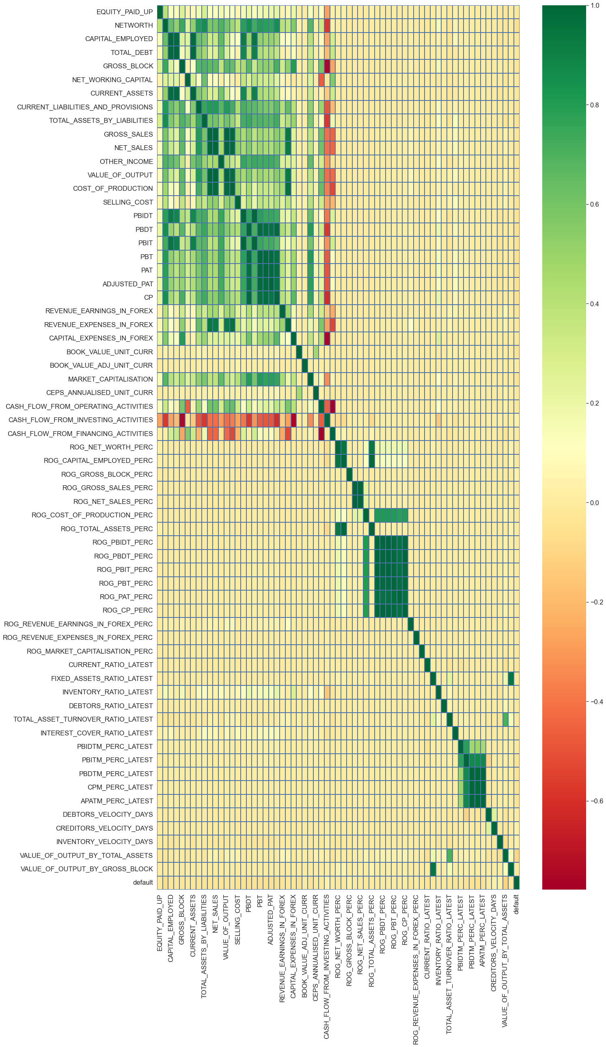

We can see that the data is highly correlated.

We have dropped highly correlated features.

The correlations for the selected 24 features are checked again.

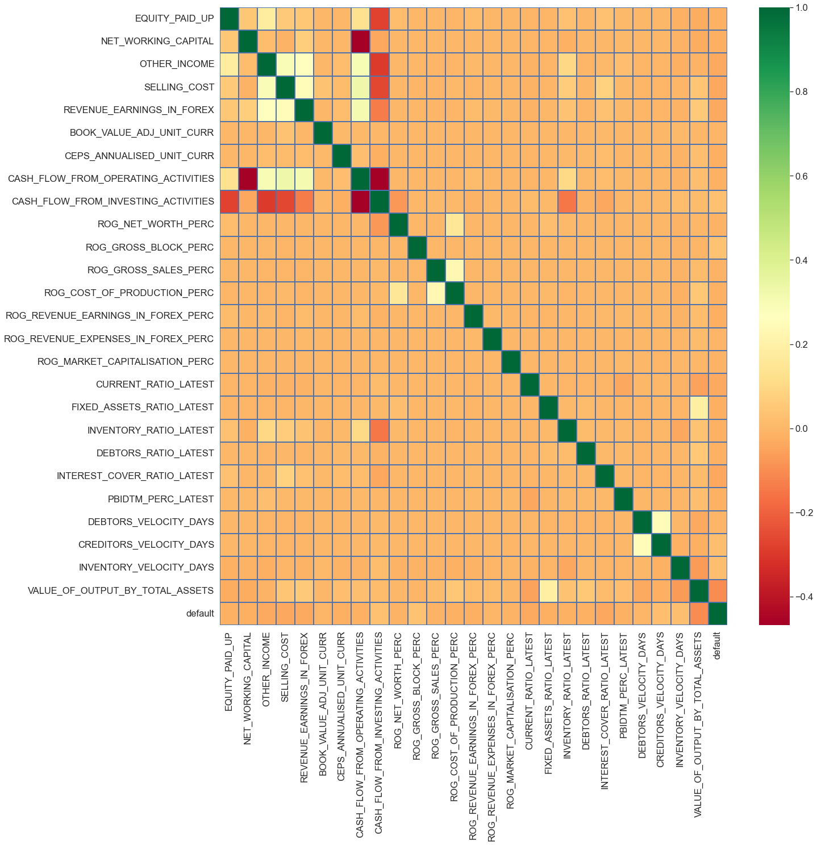

The above Data set of 24 features was further cleaned by finding out the outliers in each feature.

The outliers are replaced by Nan values

The total Nan values in the data set were close to 18 %.

Features 'ROG_REVENUE_EARNINGS_IN_FOREX_PERC', and 'ROG_REVENUE_EXPENSES_IN_FOREX_PERC' were also dropped as they had more than 30 % records missing.

The Data was subsequently split in the ratio of 67 : 33 in Train and Test data set. Care was taken that the proportion of ‘default’ present in the full data set at 89:11 was maintained for the Train and Test data as well.

The Train data was scaled using the Standard Scaler tool.

Test Data was scaled using the mean and standard deviations of the train data features.

After scaling the Null values of the Train Data were imputed using the K Nearest Neighbor tool, using 10 neighbors as the parameter.

The null values in the Test data were imputed by values as ascertained by nearest neighbors of the Train Data

**Sample train and test dataset:**

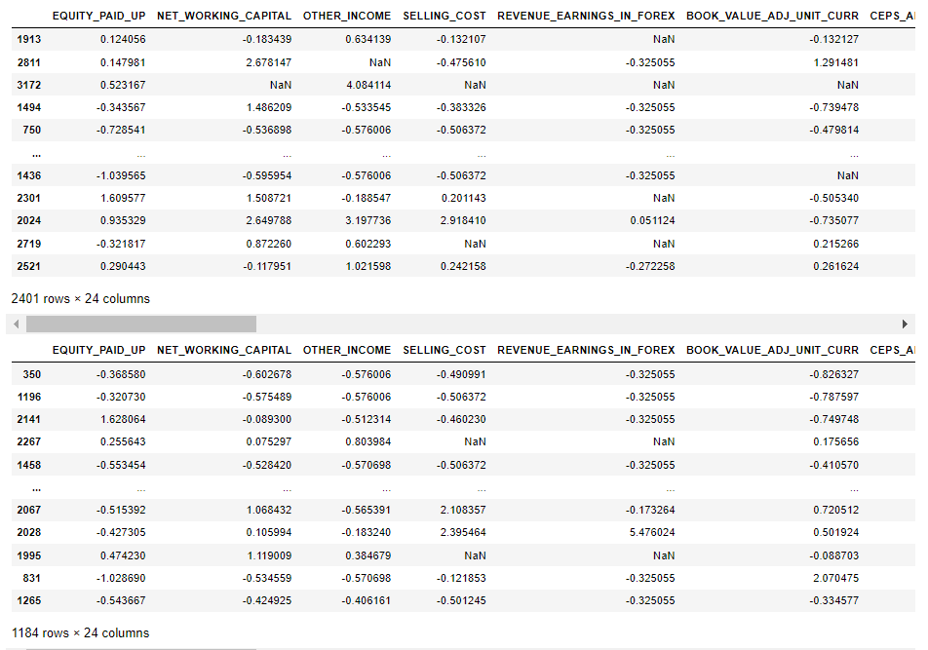

Target variable has binary values of 1 and 0. 1 means net worth next year decreases and 0 means net worth next year increases or is equal.

X_train dataset and X_test dataset is concatenated. Now above rows are X_train and below them is X_test.

Also, y_train and y_test is also concatenated.

The data is now scaled and imputed.

Let us check again correlation of our cleaned dataset.

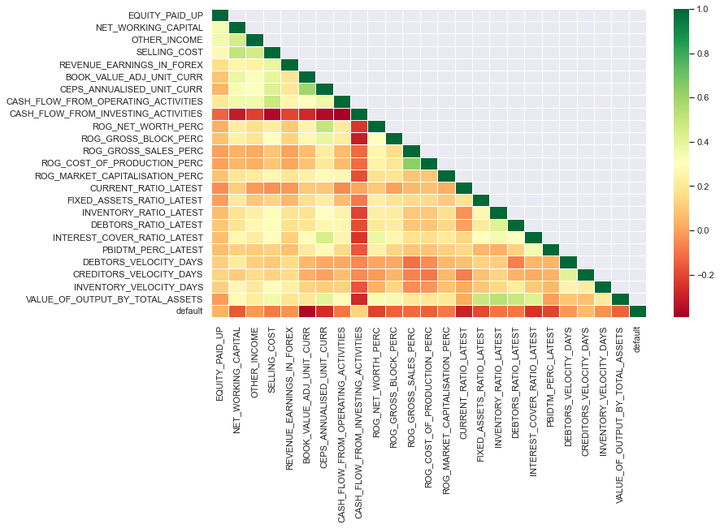

There isn’t much collinearity now.

|  | **VIF** |
| --- | --- |
| **CEPS_ANNUALISED_UNIT_CURR** | 2.342458 |
| **VALUE_OF_OUTPUT_BY_TOTAL_ASSETS** | 2.327682 |
| **SELLING_COST** | 2.001325 |
| **NET_WORKING_CAPITAL** | 1.781558 |
| **ROG_GROSS_SALES_PERC** | 1.746198 |
| **ROG_COST_OF_PRODUCTION_PERC** | 1.713397 |
| **BOOK_VALUE_ADJ_UNIT_CURR** | 1.710451 |
| **INTEREST_COVER_RATIO_LATEST** | 1.612414 |
| **OTHER_INCOME** | 1.566357 |
| **CASH_FLOW_FROM_OPERATING_ACTIVITIES** | 1.565049 |
| **INVENTORY_RATIO_LATEST** | 1.551107 |
| **DEBTORS_RATIO_LATEST** | 1.539226 |
| **ROG_NET_WORTH_PERC** | 1.480845 |
| **FIXED_ASSETS_RATIO_LATEST** | 1.433282 |
| **CASH_FLOW_FROM_INVESTING_ACTIVITIES** | 1.380912 |
| **DEBTORS_VELOCITY_DAYS** | 1.375988 |
| **ROG_GROSS_BLOCK_PERC** | 1.319728 |
| **CREDITORS_VELOCITY_DAYS** | 1.286420 |
| **EQUITY_PAID_UP** | 1.283740 |
| **PBIDTM_PERC_LATEST** | 1.279328 |
| **REVENUE_EARNINGS_IN_FOREX** | 1.261746 |
| **INVENTORY_VELOCITY_DAYS** | 1.243324 |
| **ROG_MARKET_CAPITALISATION_PERC** | 1.167552 |
| **CURRENT_RATIO_LATEST** | 1.124366 |

When we check the with VIF we find VIF values are less than 5.

We are splitting the data again into test and train from the same row from where we concatenated.

Our dependent variable is default.

**Logistic Regression Model 1:**

|  |  |  |  |
| --- | --- | --- | --- |
| Logit Regression Results | | | |
| **Dep. Variable:** | default | **No. Observations:** | 2401 |
| **Model:** | Logit | **Df Residuals:** | 2376 |
| **Method:** | MLE | **Df Model:** | 24 |
| **Date:** | Sun, 20 Nov 2022 | **Pseudo R-squ.:** | 0.5288 |
| **Time:** | 13:25:04 | **Log-Likelihood:** | -387.99 |
| **converged:** | True | **LL-Null:** | -823.35 |
| **Covariance Type:** | nonrobust | **LLR p-value:** | 2.303e-168 |

|  |  |  |  |  |  |  |
| --- | --- | --- | --- | --- | --- | --- |
|  | **coef** | **std err** | **z** | **P>|z|** | **[0.025** | **0.975]** |
| **Intercept** | -4.8395 | 0.240 | -20.127 | 0.000 | -5.311 | -4.368 |
| **EQUITY_PAID_UP** | 0.1146 | 0.107 | 1.068 | 0.286 | -0.096 | 0.325 |
| **NET_WORKING_CAPITAL** | -0.2913 | 0.159 | -1.829 | 0.067 | -0.603 | 0.021 |
| **OTHER_INCOME** | 0.3743 | 0.128 | 2.935 | 0.003 | 0.124 | 0.624 |
| **SELLING_COST** | 0.4902 | 0.149 | 3.280 | 0.001 | 0.197 | 0.783 |
| **REVENUE_EARNINGS_IN_FOREX** | -0.0241 | 0.115 | -0.210 | 0.833 | -0.249 | 0.201 |
| **BOOK_VALUE_ADJ_UNIT_CURR** | -3.2946 | 0.278 | -11.858 | 0.000 | -3.839 | -2.750 |
| **CEPS_ANNUALISED_UNIT_CURR** | -0.2280 | 0.181 | -1.259 | 0.208 | -0.583 | 0.127 |
| **CASH_FLOW_FROM_OPERATING_ACTIVITIES** | -0.1293 | 0.140 | -0.924 | 0.355 | -0.404 | 0.145 |
| **CASH_FLOW_FROM_INVESTING_ACTIVITIES** | 0.1717 | 0.148 | 1.163 | 0.245 | -0.118 | 0.461 |
| **ROG_NET_WORTH_PERC** | -0.1415 | 0.121 | -1.168 | 0.243 | -0.379 | 0.096 |
| **ROG_GROSS_BLOCK_PERC** | -0.0819 | 0.157 | -0.522 | 0.602 | -0.389 | 0.226 |
| **ROG_GROSS_SALES_PERC** | 0.1560 | 0.134 | 1.168 | 0.243 | -0.106 | 0.418 |
| **ROG_COST_OF_PRODUCTION_PERC** | -0.4813 | 0.134 | -3.579 | 0.000 | -0.745 | -0.218 |
| **ROG_MARKET_CAPITALISATION_PERC** | -0.0020 | 0.106 | -0.019 | 0.985 | -0.210 | 0.206 |
| **CURRENT_RATIO_LATEST** | -1.5085 | 0.181 | -8.356 | 0.000 | -1.862 | -1.155 |
| **FIXED_ASSETS_RATIO_LATEST** | -0.4430 | 0.203 | -2.186 | 0.029 | -0.840 | -0.046 |
| **INVENTORY_RATIO_LATEST** | -0.0386 | 0.129 | -0.299 | 0.765 | -0.292 | 0.215 |
| **DEBTORS_RATIO_LATEST** | -0.0445 | 0.126 | -0.354 | 0.724 | -0.291 | 0.202 |
| **INTEREST_COVER_RATIO_LATEST** | -0.3723 | 0.157 | -2.369 | 0.018 | -0.680 | -0.064 |
| **PBIDTM_PERC_LATEST** | -0.1880 | 0.116 | -1.623 | 0.105 | -0.415 | 0.039 |
| **DEBTORS_VELOCITY_DAYS** | 0.1628 | 0.108 | 1.503 | 0.133 | -0.050 | 0.375 |
| **CREDITORS_VELOCITY_DAYS** | 0.1500 | 0.100 | 1.497 | 0.134 | -0.046 | 0.346 |
| **INVENTORY_VELOCITY_DAYS** | 0.0018 | 0.117 | 0.016 | 0.988 | -0.227 | 0.231 |
| **VALUE_OF_OUTPUT_BY_TOTAL_ASSETS** | 0.3834 | 0.165 | 2.328 | 0.020 | 0.061 | 0.706 |

Possibly complete quasi-separation: A fraction 0.14 of observations can be  
perfectly predicted. This might indicate that there is complete  
quasi-separation. In this case some parameters will not be identified.

There are many features with P_value more than 0.05. Hence those features are dropped and the model is built again.

**Model 2:**

|  |  |  |  |
| --- | --- | --- | --- |
| Logit Regression Results | | | |
| **Dep. Variable:** | default | **No. Observations:** | 2401 |
| **Model:** | Logit | **Df Residuals:** | 2392 |
| **Method:** | MLE | **Df Model:** | 8 |
| **Date:** | Sun, 20 Nov 2022 | **Pseudo R-squ.:** | 0.5150 |
| **Time:** | 13:25:05 | **Log-Likelihood:** | -399.33 |
| **converged:** | True | **LL-Null:** | -823.35 |
| **Covariance Type:** | nonrobust | **LLR p-value:** | 9.034e-178 |

|  |  |  |  |  |  |  |
| --- | --- | --- | --- | --- | --- | --- |
|  | **coef** | **std err** | **z** | **P>|z|** | **[0.025** | **0.975]** |
| **Intercept** | -4.7205 | 0.229 | -20.634 | 0.000 | -5.169 | -4.272 |
| **NET_WORKING_CAPITAL** | -0.3027 | 0.149 | -2.028 | 0.043 | -0.595 | -0.010 |
| **OTHER_INCOME** | 0.4031 | 0.118 | 3.424 | 0.001 | 0.172 | 0.634 |
| **SELLING_COST** | 0.4977 | 0.130 | 3.838 | 0.000 | 0.244 | 0.752 |
| **BOOK_VALUE_ADJ_UNIT_CURR** | -3.4553 | 0.270 | -12.793 | 0.000 | -3.985 | -2.926 |
| **ROG_COST_OF_PRODUCTION_PERC** | -0.4675 | 0.110 | -4.256 | 0.000 | -0.683 | -0.252 |
| **CURRENT_RATIO_LATEST** | -1.4824 | 0.164 | -9.021 | 0.000 | -1.804 | -1.160 |
| **INTEREST_COVER_RATIO_LATEST** | -0.4515 | 0.138 | -3.261 | 0.001 | -0.723 | -0.180 |
| **PBIDTM_PERC_LATEST** | -0.2307 | 0.111 | -2.077 | 0.038 | -0.448 | -0.013 |

Possibly complete quasi-separation: A fraction 0.13 of observations can be  
perfectly predicted. This might indicate that there is complete  
quasi-separation. In this case some parameters will not be identified.

WE have completed building a model with only 8 features and discarding others to build an efficient model.

Confusion Matrix:

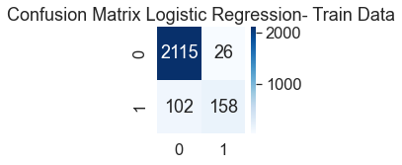

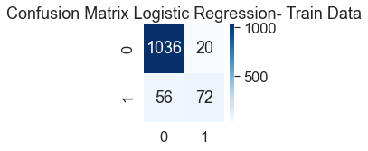

Classification Report:

Classification Report - Logistic Regression- Train Data

precision recall f1-score support

0 0.95 0.99 0.97 2141

1 0.86 0.61 0.71 260

accuracy 0.95 2401

macro avg 0.91 0.80 0.84 2401

weighted avg 0.94 0.95 0.94 2401

Classifiaction Report - Logistic Regression- Test Data

precision recall f1-score support

0 0.95 0.98 0.96 1056

1 0.78 0.56 0.65 128

accuracy 0.94 1184

macro avg 0.87 0.77 0.81 1184

weighted avg 0.93 0.94 0.93 1184

We are further improving the model by optimising the threshold level to 0.165.

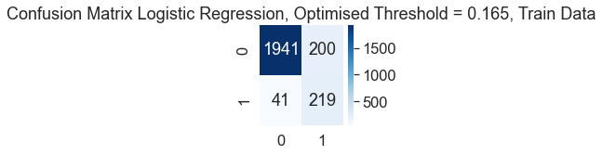

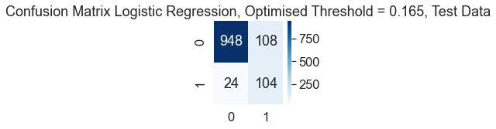

Classification Report - Logistic Regression, Optimised Threshold = 0.165, Train Data

precision recall f1-score support

0 0.98 0.91 0.94 2141

1 0.52 0.84 0.65 260

accuracy 0.90 2401

macro avg 0.75 0.87 0.79 2401

weighted avg 0.93 0.90 0.91 2401

Classification Report - Logistic Regression, Optimised Threshold = 0.165, Test Data

precision recall f1-score support

0 0.98 0.90 0.93 1056

1 0.49 0.81 0.61 128

accuracy 0.89 1184

macro avg 0.73 0.86 0.77 1184

weighted avg 0.92 0.89 0.90 1184

We find that recall for 1 has improved but precision has gone down.

We will now balance the data using SMOTE

Sampling Strategy Ratio - Initial proportion of ‘default’ in original data is 388 / 3197 = 0.12.

Using the SMOTE, we iterate the sampling strategy ratio and see that by increasing the proportion of default by engineering synthetic data, we get models which over fit. The most ideal ratio ascertained is 0.15, where there was an improvement in the model performance and the Recall and Precision readings for ‘1’ were reasonably together.

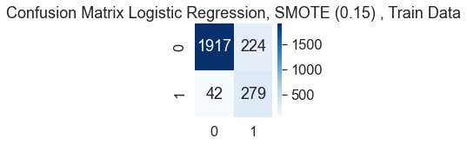

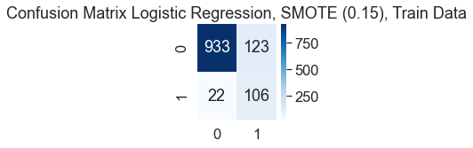

Classification Report- Logistic Regression, SMOTE (0.15) , Train Data

precision recall f1-score support

0 0.98 0.90 0.94 2141

1 0.55 0.87 0.68 321

accuracy 0.89 2462

macro avg 0.77 0.88 0.81 2462

weighted avg 0.92 0.89 0.90 2462

Classification Report- Logistic Regression, SMOTE (0.15) , Test Data

precision recall f1-score support

0 0.98 0.88 0.93 1056

1 0.46 0.83 0.59 128

accuracy 0.88 1184

macro avg 0.72 0.86 0.76 1184

weighted avg 0.92 0.88 0.89 1184

**Random Forest Model:**

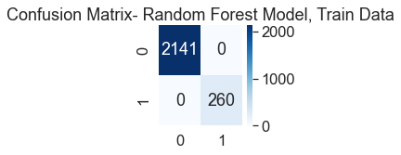

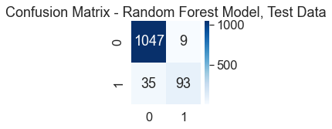

Classification Report- Random Forest Model, Train Data

precision recall f1-score support

0 1.00 1.00 1.00 2141

1 1.00 1.00 1.00 260

accuracy 1.00 2401

macro avg 1.00 1.00 1.00 2401

weighted avg 1.00 1.00 1.00 2401

Classification Report- Random Forest Model, Train Data

precision recall f1-score support

0 0.97 0.99 0.98 1056

1 0.91 0.73 0.81 128

accuracy 0.96 1184

macro avg 0.94 0.86 0.89 1184

weighted avg 0.96 0.96 0.96 1184

We have a over fit model here with random forest model.

We will use GridSearch module to improve the model.

Parameters that we have with this module are:

max_depth': [3, 5, 7],

'min_samples_leaf': [5, 10, 15],

'min_samples_split': [15, 30, 15],

'n_estimators': [25, 50]

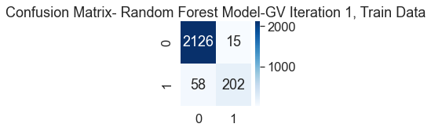

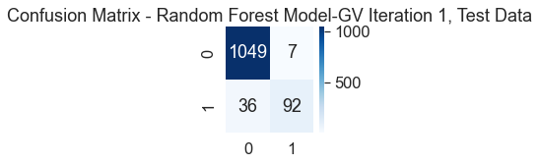

Classification Report- Random Forest Model-GV Iteration 1, Train Data

precision recall f1-score support

0 0.97 0.99 0.98 2141

1 0.93 0.78 0.85 260

accuracy 0.97 2401

macro avg 0.95 0.88 0.92 2401

weighted avg 0.97 0.97 0.97 2401

Classification Report- Random Forest Model-GV Iteration 1 Train Data

precision recall f1-score support

0 0.97 0.99 0.98 1056

1 0.93 0.72 0.81 128

accuracy 0.96 1184

macro avg 0.95 0.86 0.90 1184

weighted avg 0.96 0.96 0.96 1184

We have a random forest model with a 71% recall and 93% precision. And these results are similar in train and test data.

This model is best random forest model.

Now that we have completed model building we can compare all the models and we find that the best model is the random forest model with GridSearch parameters. Hence it should be chosen.

**ROC curve for random forest model:**

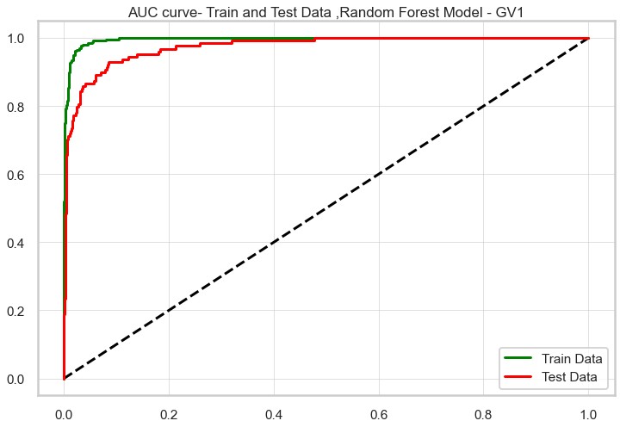

**Draw Stock Price Graph(Stock Price vs Time):**

Infosys

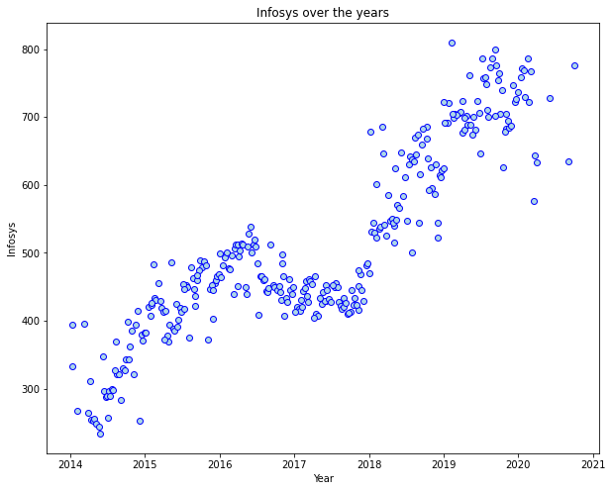

count 314.000000

mean 511.340764

std 135.952051

min 234.000000

25% 424.000000

50% 466.500000

75% 630.750000

max 810.000000

Name: infosys, dtype: float64

The stocks are rising for Infosys.

Axis Bank

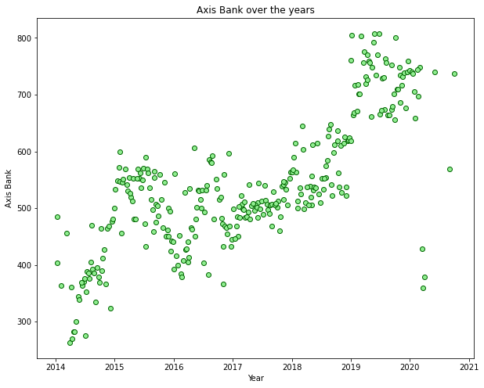

count 314.000000

mean 540.742038

std 115.835569

min 263.000000

25% 470.500000

50% 528.000000

75% 605.250000

max 808.000000

Name: axis_bank, dtype: float64

Stocks for axis bank has also been rising.

**Calculate Returns for all stocks with inference**

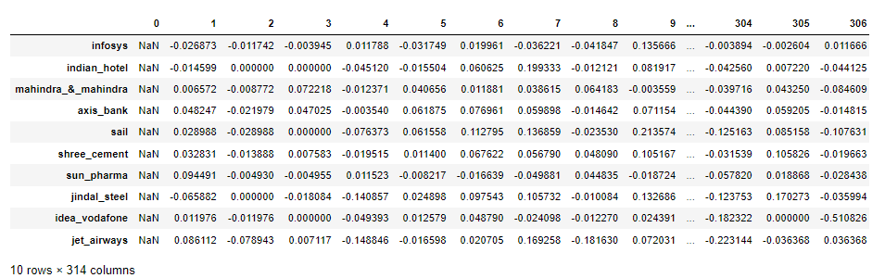

Weekly returns on stocks of all the companies can be see in the above chart.

**Calculate Stock Means and Standard Deviation for all stocks with inference**

infosys 0.035070

indian_hotel 0.047131

mahindra_&_mahindra 0.040169

axis_bank 0.045828

sail 0.062188

shree_cement 0.039917

sun_pharma 0.045033

jindal_steel 0.075108

idea_vodafone 0.104315

jet_airways 0.097972

dtype: float64

**Draw a plot of Stock Means vs Standard Deviation and state your inference**

